9/16/2026
Instructor: Sir M. Fahad Qasim
Submitted by: Wasif Ali
Reg id: 245187
Class: BSCS F24 B


BASICS OF HTML
Full-Stack Development Lab
Lab No 01
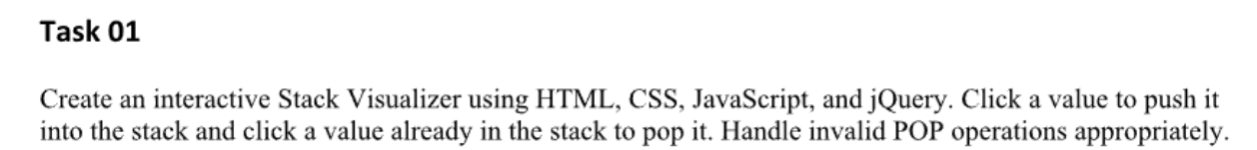
Code:
Index.html
<!DOCTYPE html>
<html lang="en">

<head>
<meta charset="UTF-8">
<meta name="viewport" content="width=device-width, initial-scale=1.0">
<title>Stack Visualizer</title>
<link rel="stylesheet" href="style.css">
<!-- Include jQuery -->
<script src="https://code.jquery.com/jquery-3.6.0.min.js"></script>
</head>

<body>
<h2>Stack Visualizer (LIFO)</h2>
<p>Click a number to PUSH it to the stack:</p>

<div class="input-values">
<button class="push-btn">10</button>
<button class="push-btn">20</button>
<button class="push-btn">30</button>
<button class="push-btn">40</button>
</div>

<p>Click the top item in the stack to POP it:</p>
<div id="stack-container">

</div>

<script src="script.js"></script>
</body>

</html>

Style.css
body {
font-family: Arial, sans-serif;
text-align: center;
margin: 40px;
}

.input-values button {
padding: 10px 20px;
margin: 5px;
font-size: 16px;
cursor: pointer;
background-color: #4CAF50;
color: white;
border: none;
border-radius: 4px;
}

#stack-container {
width: 200px;
min-height: 250px;
margin: 30px auto;
border: 4px solid #333;
border-top: none;
display: flex;
flex-direction: column;
justify-content: flex-end;
padding: 10px;
background-color: #f9f9f9;
}
.stack-item {
background-color: #2196F3;
color: white;
padding: 15px;
margin-bottom: 5px;
text-align: center;
font-weight: bold;
cursor: pointer;
border: 1px solid #1976D2;
}
.stack-item:hover {
background-color: #1976D2;
}

Script.js
$(document).ready(function () {

$('.push-btn').click(function () {

let value = $(this).text();

let newItem = $('<div class="stack-item"></div>').text(value);

$('#stack-container').prepend(newItem);
});

$('#stack-container').on('click', '.stack-item', function () {

if ($(this).is(':first-child')) {
$(this).remove();
} else {

alert("Invalid POP! In a Stack, you can only pop the top-most element.");
}
});

});

OUTPUT:
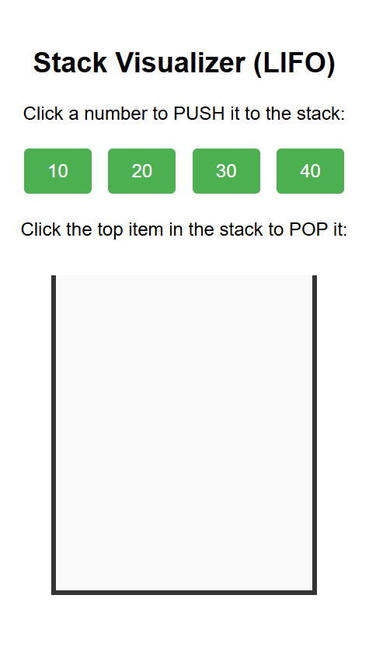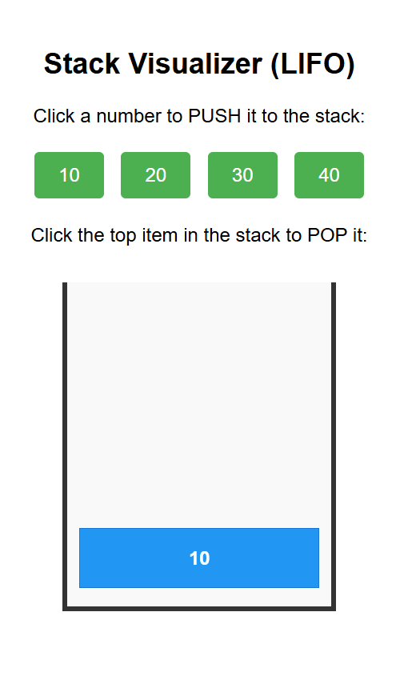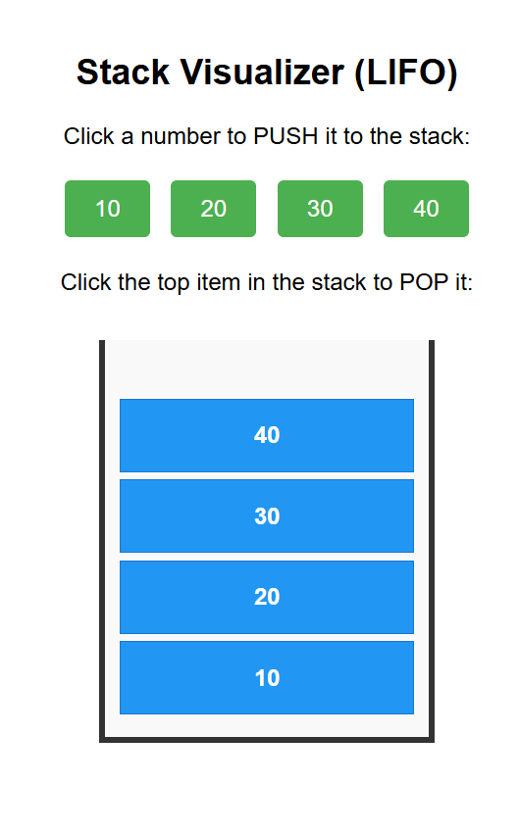

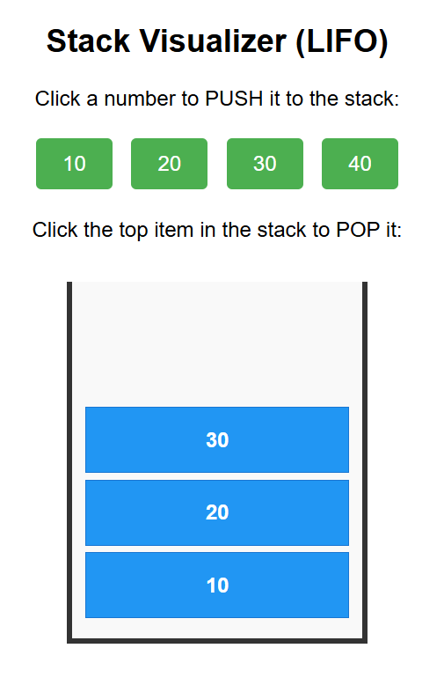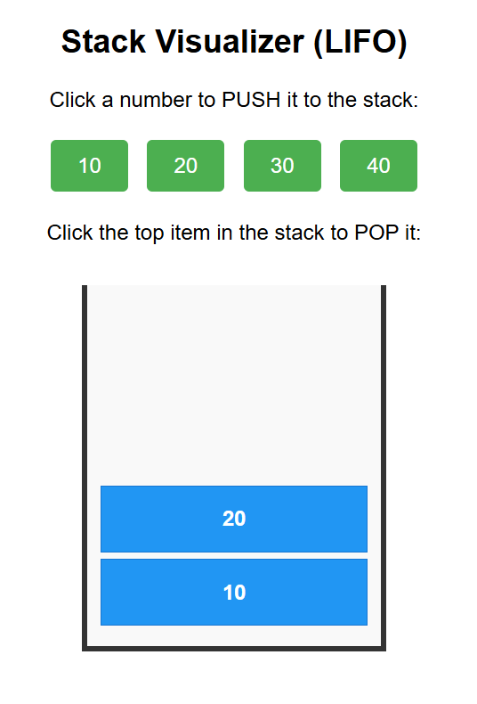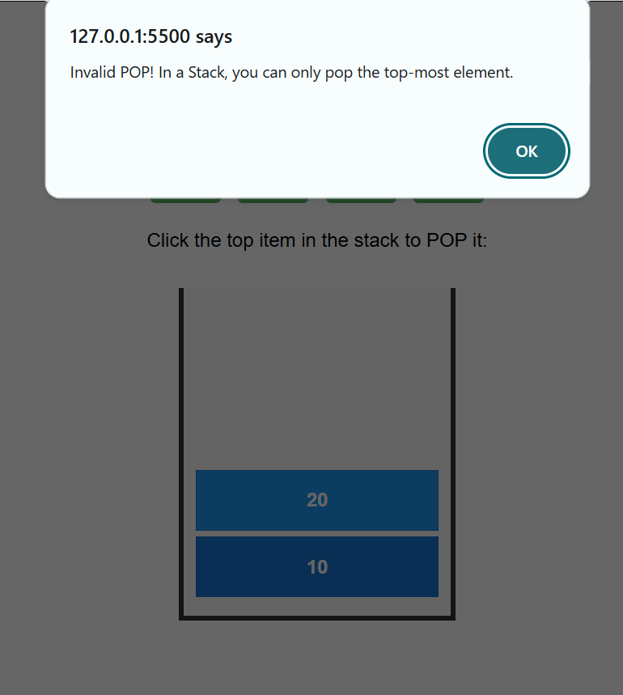

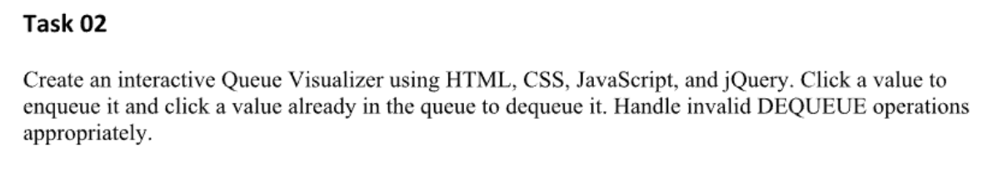
Code:
Index.html
<!DOCTYPE html>
<html lang="en">

<head>
<meta charset="UTF-8">
<meta name="viewport" content="width=device-width, initial-scale=1.0">
<title>Queue Visualizer</title>
<link rel="stylesheet" href="style.css">
<!-- Include jQuery -->
<script src="https://code.jquery.com/jquery-3.6.0.min.js"></script>
</head>

<body>
<h2>Queue Visualizer (FIFO)</h2>
<p>Click a number to ENQUEUE (add to back):</p>

<div class="input-values">
<button class="enq-btn">A</button>
<button class="enq-btn">B</button>
<button class="enq-btn">C</button>
<button class="enq-btn">D</button>
</div>

<p>Click the front item in the queue to DEQUEUE it:</p>
<div class="queue-wrapper">
<span class="label">Front (Exit) &lt;--</span>
<div id="queue-container">

</div>
<span class="label">&lt;-- Back (Entry)</span>
</div>
<script src="script.js"></script>
</body>
</html>

Style.css
body {
font-family: Arial, sans-serif;
text-align: center;
margin: 40px;
}

.input-values button {
padding: 10px 20px;
margin: 5px;
font-size: 16px;
cursor: pointer;
background-color: #FF9800;
color: white;
border: none;
border-radius: 4px;
}

.queue-wrapper {
display: flex;
align-items: center;
justify-content: center;
margin-top: 30px;
}

.label {
font-weight: bold;
color: #555;
margin: 0 15px;
}

#queue-container {
display: flex;
flex-direction: row;
/* Horizontal line */
min-width: 300px;
height: 60px;
border-top: 4px solid #333;
border-bottom: 4px solid #333;
background-color: #f9f9f9;
padding: 5px;
overflow-x: auto;
}

.queue-item {
background-color: #9C27B0;
color: white;
min-width: 50px;
height: 100%;
margin-right: 5px;
display: flex;
align-items: center;
justify-content: center;
font-weight: bold;
cursor: pointer;
border: 1px solid #7B1FA2;
}

.queue-item:hover {
background-color: #7B1FA2;
}

Script.js
$(document).ready(function () {

$('.enq-btn').click(function () {

let value = $(this).text();

let newItem = $('<div class="queue-item"></div>').text(value);

$('#queue-container').append(newItem);
});

$('#queue-container').on('click', '.queue-item', function () {

if ($(this).is(':first-child')) {
$(this).remove();
} else {
alert("Invalid DEQUEUE! In a Queue, you can only remove the element at the front.");
}
});

});
OUTPUT:


